Setting up/Updating your Outlook Email Signature
(updated February 2015)

It is important that our email signatures are standardized throughout the organization for reasons of consistency and compliance. During event periods, our signatures are also used as a promotional tool.

When setting up your signature for the first time, you may copy the new and reply signatures of your manager and paste this into the Signature section in Outlook. (See instructions below on how to do this)

Typically, signature change requests come from the Community Relations team. Highlight the entire signature in their email (including the confidentiality section and address at the bottom) and right click the mouse and select COPY to copy the signature.
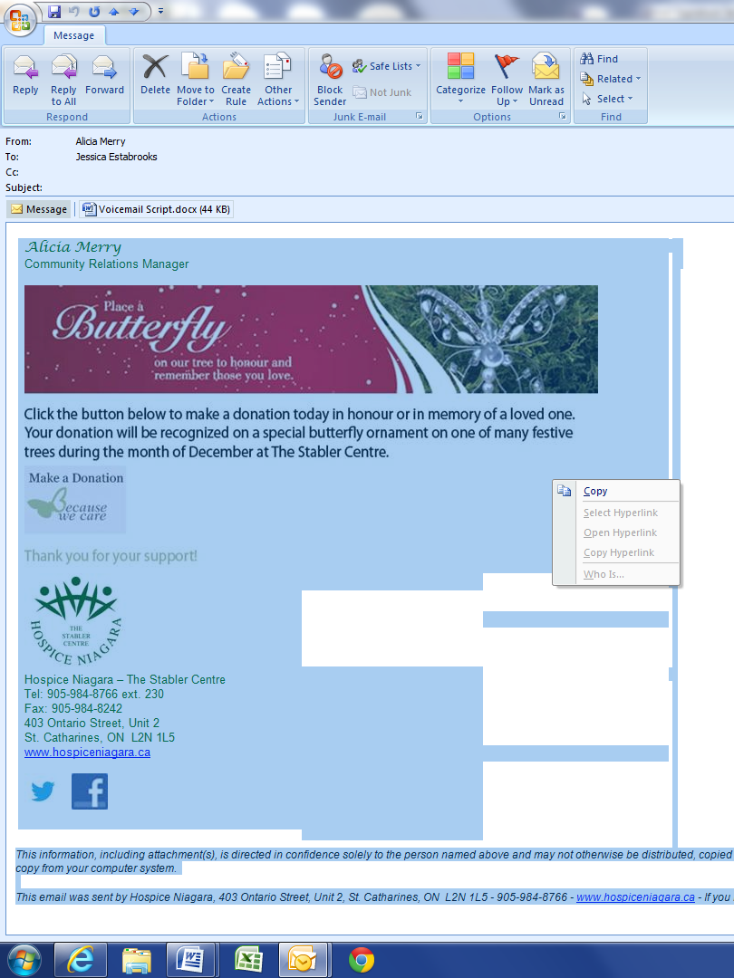

- In Outlook, go to Tools in the menu bar.
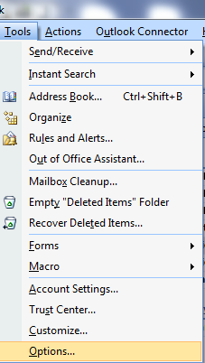
- Select Options

- Select Mail Format, then Signatures…
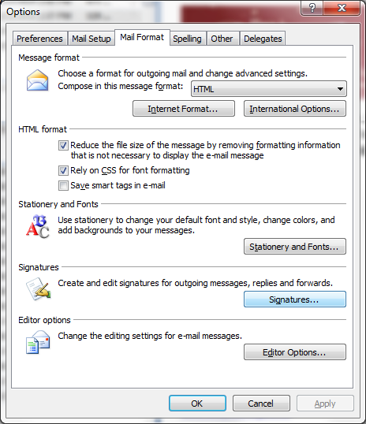

- Select the NEW button and type in a name for your new signature (i.e. Holiday Butterfly).
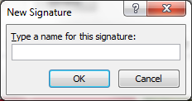

- Select OK.

- Right click your mouse in the text body and select PASTE to paste the signature into the text body area.

- You then need to update the name, title and extension with your information using the backspace key to erase the other employee’s information and then type your own. It is important not to change the formatting at all.
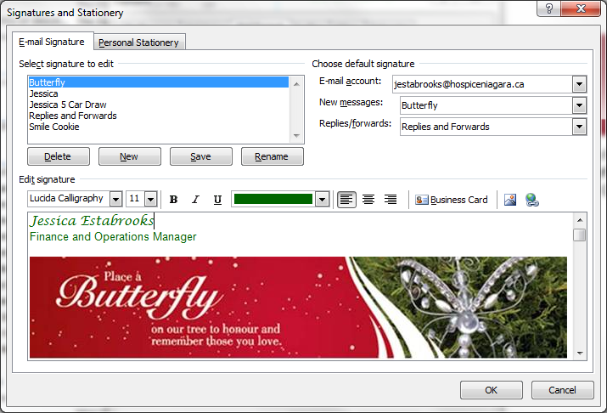

- Select the SAVE button

- On the same Signature set up screen, under Choose default signature, select the new signature that you created for “New Messages”.

- If the Community Relations team asked that you update your Reply Email signature, repeat the process for that signature and select your new signature for the Replies/forwards signature default.

- Select OK.

